**JOB APPLICATION TRACKING SYSTEM**

**Job Application Tracking System**

**Project Description**

Create a CRM Application which helps the applicant to track the No. of jobs he applied and helps him to find the job posted by the various recruiters, find the best attributes to be involved

to run the process in a smooth way and easily to track.

**Create a Data Model for the App**

To make the existing app more efficient for the Job application we create custom objects and relationships to store and access the data more efficiently.

**Introduction**

Are you new to Salesforce? Not sure exactly what it is, or how to use it? Don’t know where you should start on your learning journey? If you’ve answered yes to any of these questions, then you’re in the right place. This module is for you.

Welcome to Salesforce! Salesforce is game-changing technology, with a host of productivity-boosting features, that will help you sell smarter and faster. As you work toward your badge for this module, we’ll take you through these features and answer the question, “What is Salesforce, anyway?”

**Milestone 1- Salesforce:**

**What Is Salesforce?**

Salesforce is your customer success platform, designed to help you sell, service, market, analyze, and connect with your customers.

Salesforce has everything you need to run your business from anywhere. Using standard products and features, you can manage relationships with prospects and customers, collaborate and engage with employees and partners, and store your data securely in the cloud.

So what does that really mean? Well, before Salesforce, your contacts, emails, follow-up tasks, and prospective deals might have been organized something like this:

**Activity1:**

**Creating a Salesforce Developer Org:**

A Developer org has all the features and licenses you need to get started with Salesforce.

1. Search Developer.salesforce.com

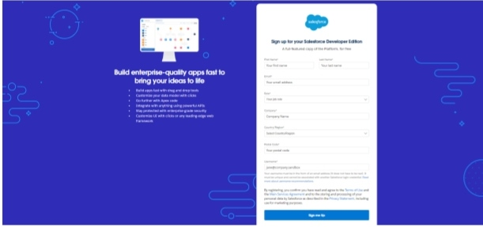

2.Enter the following details like First name, last name, Email, Role, Company, Country/Region, Postal code, and Username must be unique.

3. Click sign me up, after a few min you will reserve a mail salesforce org and by using the verify account link you can create your new password.

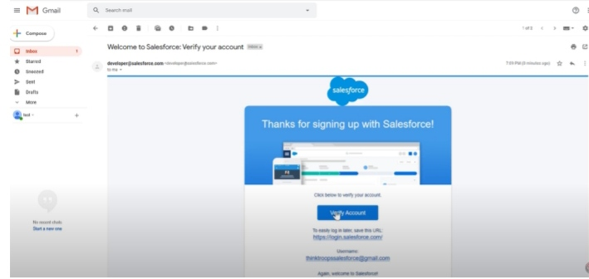

4. Click save.

5. Search login.salesforce.com

6. By using username and password you can into the salesforce org.

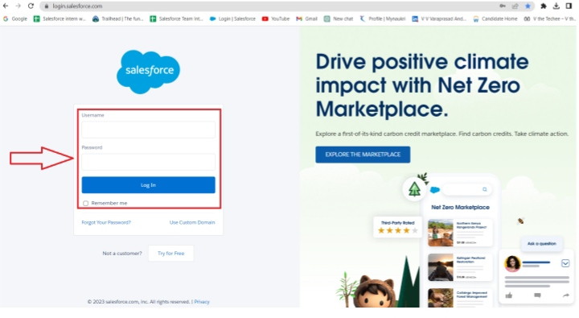

The setup page will appear as below.

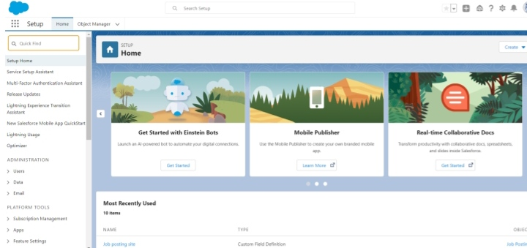

**Milestone 2-Object:**

What is an object?

Salesforce objects are database tables that permit you to store data that is specific to anorganization. It consists of fields (columns) and records (rows).

Salesforce objects are of two types:

● Standard Objects: Standard objects are the kind of objects that are provided by salesforce.com such as users, contracts, reports, dashboards, etc.

● Custom Objects: Custom objects are those objects that are created by users. They supply information that is unique and essential to their organization. They are the heart of any application and provide a structure for sharing data.

**Activity 1:**

**Create a custom object for Recruiter:**

To create a custom object, follow these steps:

1. From setup click on object manager.

2. Click create, select custom object.

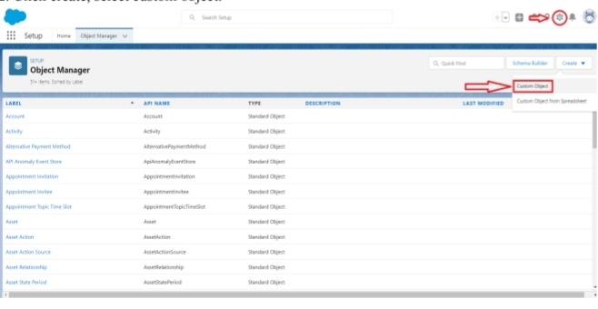

3. Fill in the label as " Recruiter ".

4. Fill in the plural label as " Recruiters".

5. Record name: " Recruiter Number"

6. Select the data type as "Auto Number".

7. Under display format enter "REC-{0000}".

8. Enter starting number as 1.

9. In the Optional Features section, select Allow Reports and Track Field History.

10. In the Deployment Status section, ensure Deployed is selected.

11. In the Search Status section, select Allow Search.

12. In the Object Creation Options section, select Add Notes and Attachments

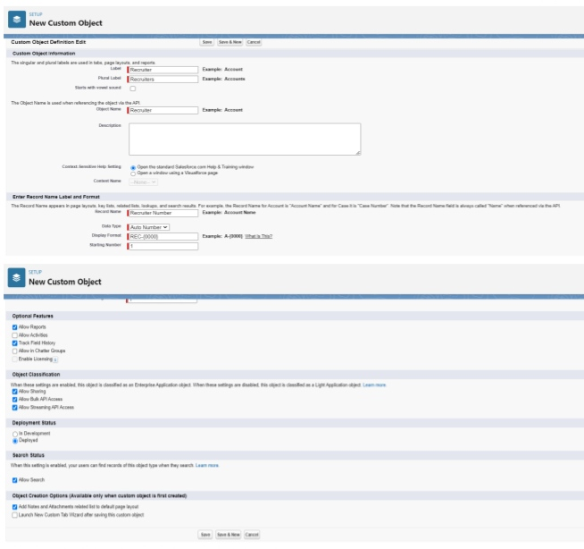

13. Leave everything else as is, and click Save.

**Activity 2:**

1. Create a Jobs, Candidate, Job Application Object and Tab.

Note :- Follow the steps from the above activity

**Milestone 3- Fields:**

What are fields?

Fields in Salesforce represents what the columns represent in relational databases. It can store data values which are required for a particular object in a record.

There are 2 types of fields in salesforce:

● Standard fields: There are four standard fields in every custom object that are Created By, Last Modified By, Owner, and the field created at the time of the creation of an object. These fields cannot be deleted or edited and they are always required. For standard objects, the fields which are present by default in them and cannot be deleted from standard objects are standard fields.

● Custom fields: The Custom fields which are added by the administrator/developer to meet the business requirements of any organization. They may or may not be required.

**Activity 1:**

**Create the custom fields:**

1. Click the object manager tab, Select the object for which you have to create the fields and relationships.

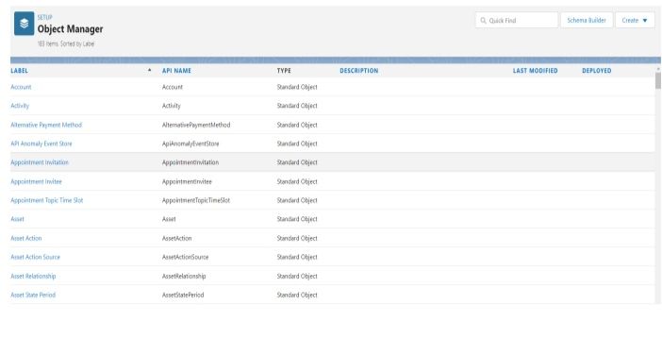

1. From the sidebar, Fields & Relationships. Notice that there are already some fields there. Those are the standard fields.

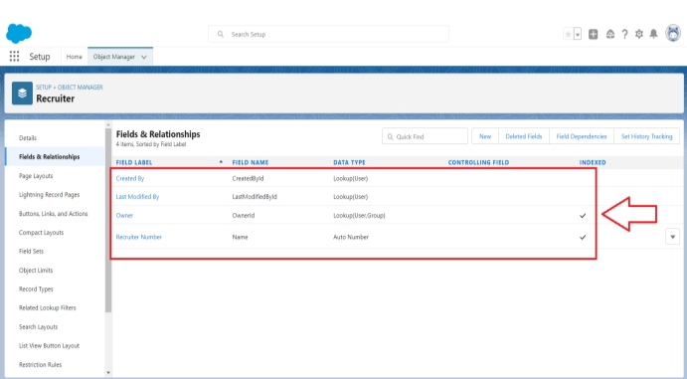

1. Click New to create a custom field. Tip: Before creating a new field, do a quick search to make sure a similar one doesn’t already exist.

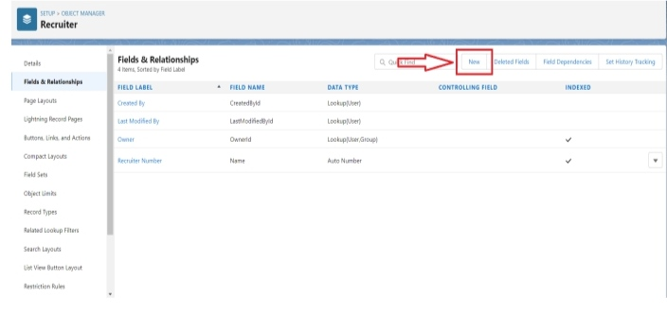

1. Click on the new to create a field.
2. Choose the data types as a Text, click next

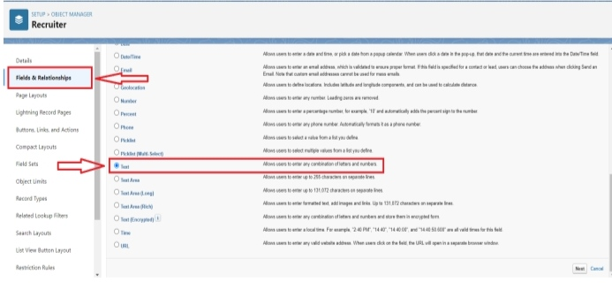

1. Enter field label, length and Name and click next

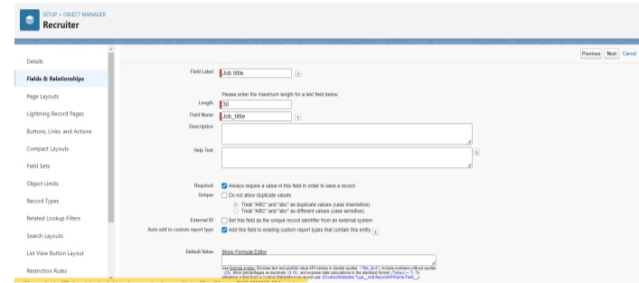

1. Select the profile to which you want to grant edit access to this field via field-level security. The field will be hidden from all profiles if you do not add it to field-level security. Click next
2. Select the page layouts that should include this field.
3. Click New.

**Activity 2:**

**Creation of Master-detail relationship:**

1. From Setup, go to Object Manager
2. On the sidebar, click Fields & Relationships.
3. Click New.

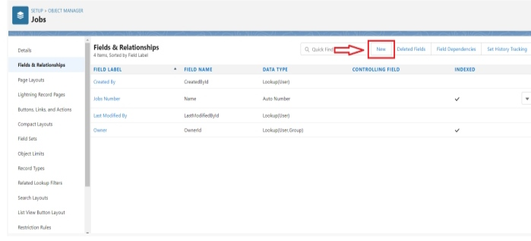

1. Choose Master-detail Relationship and click Next

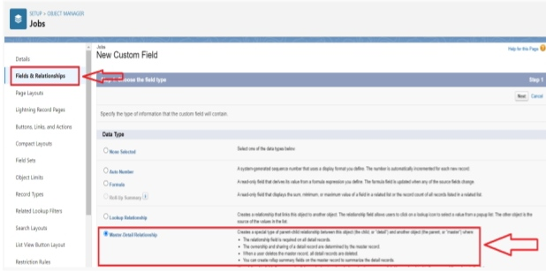

1. Choose the related object select that object.

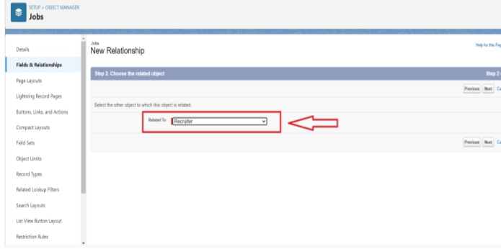

1. Enter the label and name for the lookup field

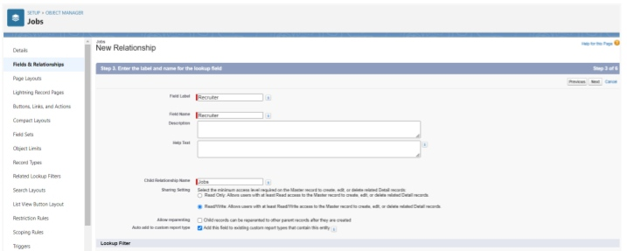

1. Click Next, Next, and Save

**Activity 3:**

**Create a new custom field:**

1. From Setup, go to object Manager
2. On the sidebar, click Fields & Relationships.
3. Click New.



1. Choose the data type Text Area click next
2. Click next and save.

**Activity 4:**

**Create a new custom field:**

1. From Setup, go to Object Manager
2. On the sidebar, click Fields & Relationships.
3. Click New.

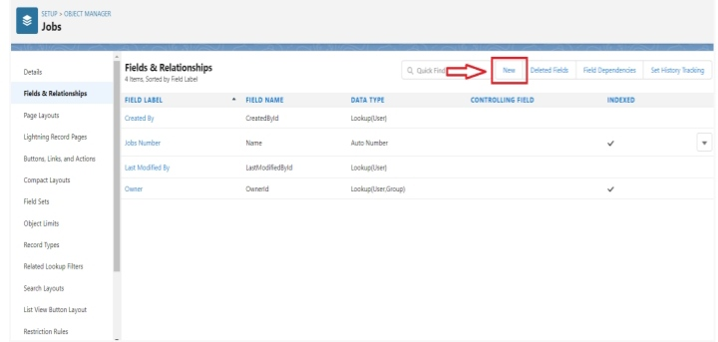

1. Choose the data type Text click next

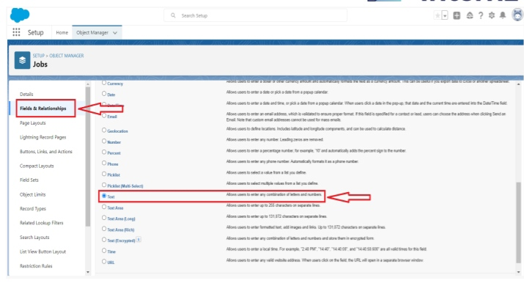

1. Enter the Field Label and field name click next

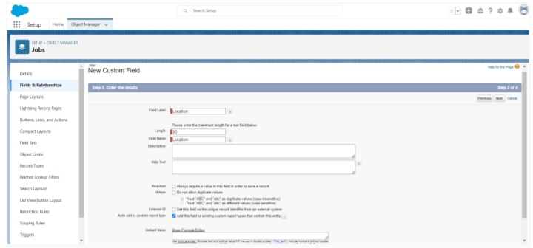

1. Click next and save

**Milestone 4-Tab:**

What is Tab?

In Salesforce, a tab is a user interface element that allows users to navigate to different sections of the platform, such as Accounts, Contacts, Leads, and Opportunities. Tabs can also be used to access custom objects and custom pages. They are typically located at the top of the screen and can be customized to fit the needs of the organization.

**Activity 1 :**

**Create a tab :**

1. Click setup

2. Search tab in Quick box then, select tab

3. Click New custom object tab section

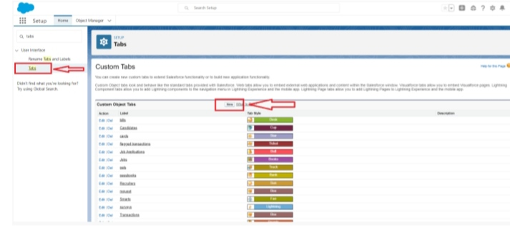

1. Select the created object Recruiter and tab style for the new custom tab.

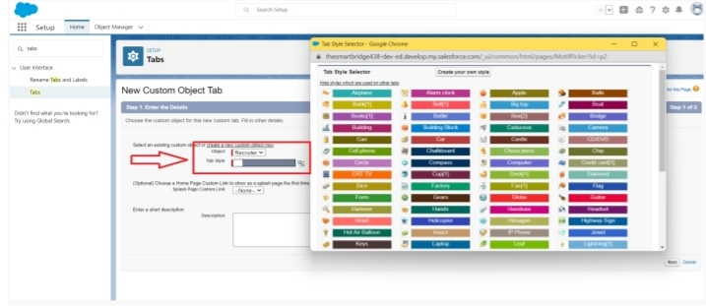

5. Select the profiles that visible in the tab

6. Click on custom apps to make visible.

7. Click save.

**Milestone 5- Profile:**

What is a profile?

A profile is a group/collection of settings and permissions that define what a user can do in salesforce. A profile controls “Object permissions, Field permissions, User permissions, Tab settings, App settings, Apex class access, Visualforce page access, Page layouts, Record Types, Login hours & Login IP ranges.

A profile can be assigned to many users, but user can be assigned single profile at a time.

**Activity 1:**

**Create a custom profile :**

1. From setup , enter profiles in Quick Find box

2. Select profiles.

3. Click clone.

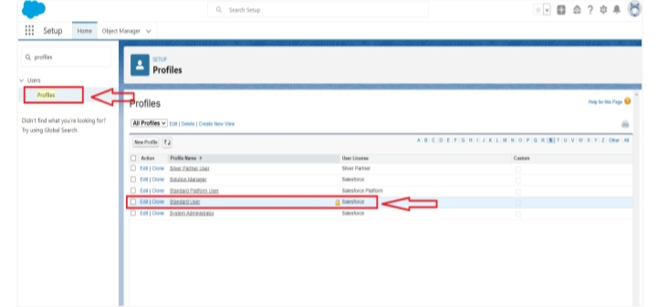

1. For Profile, enter Recruiter.

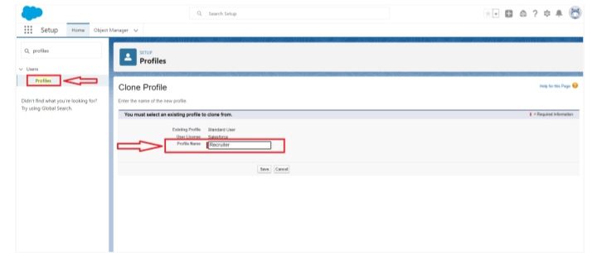

5. Click save.

**Activity 2:**

Create a profile with the profile name as “Sales Manager”.

Follow the steps from above Activity

**Milestone 6-User**

What is a user?

A user is anyone who logs in to Salesforce. Users are employees at your company, such as sales reps, managers, and IT specialists, who need access to the company's records. Every user in Salesforce has a user account. The user account identifies the user, and the user account settings determine what features and records the user can access.

**Activity 1:**

**To Create a user:**

1. From Setup, enter Users in the Quick Find box, then select Users.
2. Click New User

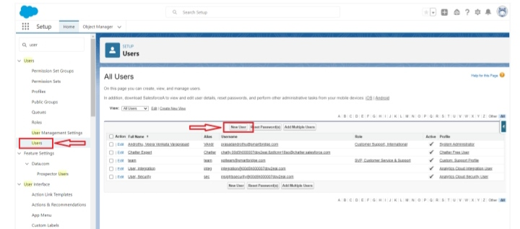

3. Enter First name as Hr and last name as Manager.

4. Enter the user’s name and email address and a unique username in the form of an email address. By default, the username is the same as the email address.

5. Then create a new role Hr Manager.

6. Select user License as Standard Platform User.

7. Select profile.

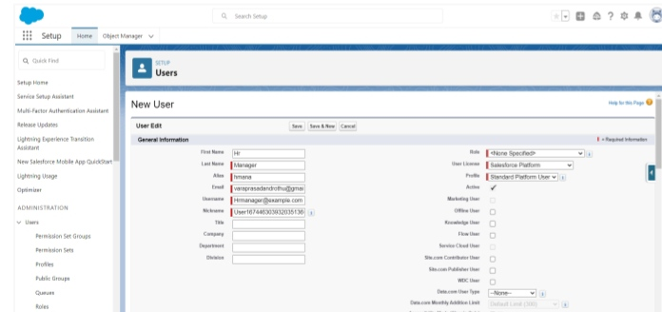

8. Click save

**Activity 2:**

Create a user with a username as “Ganesh Gelli”, and assign him the sales Manager profile.

Follow the steps from above Activity

**Milestone 7-Sharing Rules**

What are Sharing Rules?

Sharing rules help users to share records based on conditions. It is basically created for objects whose organization-wide defaults (OWD) are set to public read-only or private because sharing rules can only extend the access and not restrict it.

Types of sharing rules,

• Owner-based Sharing Rules

• Criteria-based Sharing Rules

**Activity 1:**

**Create a sharing rule**

1) Go to Sharing Settings, which can be found under the Quick Find section.

2) Scroll down and find the candidate object where a sharing rule needs to be added, and then click on New to create a new sharing rule

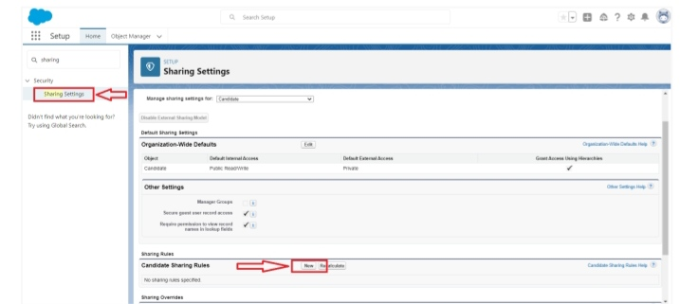

3) Add the label of the sharing rule you want to make.

4) Select your rule type based on the criteria.

5) Select the field can join immediately check field from the candidate object.

6) Select the operator as equal and value is true.

7) And in selecting the users to share with the section select roles and in that select Hr Manager.

8) And in the section of select the level of access for the users give the access Read/Write.

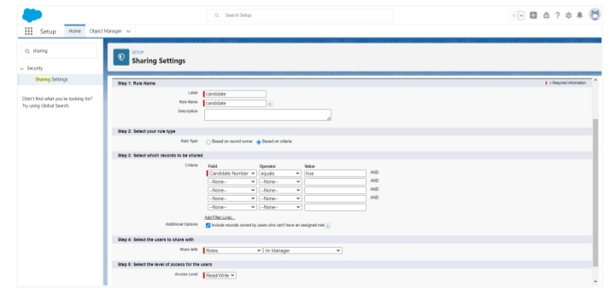

9) And save the rule.

**Activity 2:**

Create a Sharing Rule to Share the records of Job Application to Hr Manager with the Access of Read/Write.

Follow the steps from above Activity.

**Milestone 8-Reports:**

What are Reports?

A report is a list of records that meet the criteria you define. It's displayed in rows and columns, and can be filtered, grouped, or displayed in a graphical chart. Every report is stored in a folder. Folders can be public, hidden, or shared, and can be set to read-only or read/write.

**Activity 1:**

**Create a report:**

Create a report that displays rating of the account and which has type and account name.

1) Click on app launcher search for reports.

2) Click on the new report and select the category has accounts and contacts.

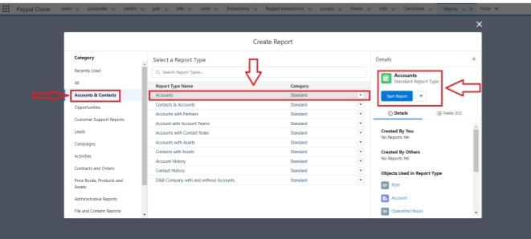

3) And the report type has accounts.

4) In the details section select the option start report.

5) In the filter pane select All accounts to show me.

6) And All time is created.

7) In the outline pane, group rows select Rating and in group columns select Account Name.

8) In the columns section add Type and Billing city.

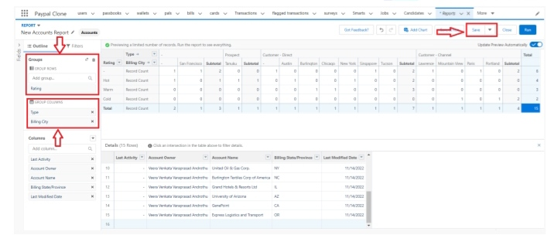

9) Save the report by giving label name and save the folder as a public folder and save the report.

**Activity 2:**

Create a Report using the Objects Jobs, Candidate and Job Application. Follow the steps from above Activity.